Physics Stage 3: Electricity and Magnetism TEST

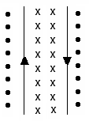
Name: ___________ ANSWERS _______________ (40 marks)
- Two current carrying wires are set up as shown.
  - Draw in the field around each wire using ‘x’ or ‘•’. (1 mark)
  - What will happen to the wires when direct current flows in each wire as shown? (No explanation required.) (1 mark)

Wires will move apart
(stronger field in the centre than outside)

- Draw the field around the following magnets. (2 marks)
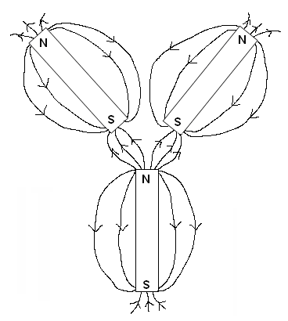
- Imagine you are driving East in a truck where the vertical component of the Earth’s magnetic field is 5.00 x 10⁻⁵ T upwards. If the axle of the truck is 2.45 m long, and the truck is travelling at 90.0 kmh⁻¹
- calculate the emf generated in the axle. (2 marks)
v = 90 ÷ 3.6 emf = Bv
= 25.0 m s⁻¹ = 5.0 x 10⁻⁵ x 25 x 2.45
= 1.23 x 10⁻³ V

- which hemisphere are you driving the truck in? Explain. (2 marks)
You are driving in the southern hemisphere as the vertical component of the earth’s magnetic field is upwards. The angle of dip is upwards in the southern hemisphere and downwards in the northern hemisphere.
- The coil ABCD, which is free to rotate about the axis XY, is placed in a magnetic field of 9.08 mT. The coil consists of 25 turns and a current of 2.20 A is passing through it. The coil is rectangular, with AB = 55.0 mm and BC = 35.0 mm.
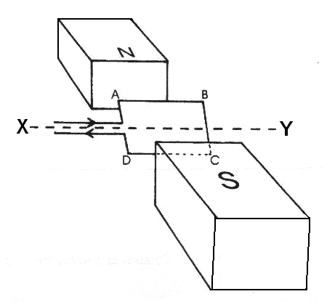
a. Calculate the maximum torque on the motor. (3 marks)

τ = nFr⊥
= n (BI)r⊥
= 25 x 9.08 x 10⁻³ x 2.2 x (2 x 0.055) x (0.5 x 0.035)
= 9.61 x 10⁻⁴ N m

- Give three ways in which the torque could be increased. (3 marks)
Increasing the number of coils.
Increasing the strength of the permanent magnets.
Increasing the current flowing through the coil.
- On the graph below, sketch the torque on the coil as it is rotated through 360⁰ from being initially horizontal. (1 marks)

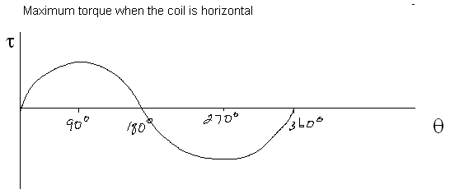
- A student set up the following circuit and recorded the current using an ammeter. The value for the ammeter was 0.300 A. After he has packed up the equipment and put it away, he realised he had forgot to measure the potential different. Assuming that the readings on his power pack were accurate, what setting did he most likely have it on? (3 marks)

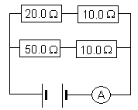
R top = 30.0 Ω R_{T} = (30⁻¹ + 60⁻¹)⁻¹
R bottom = 60.0 Ω R_{T} = 20.0 Ω

V_{T} = I_{T} x R_{T}
= 0.300 x 20.0
V_{T} = 6.00 V

Most likely had the power pack on 6 V

- A transformer is being tested. The primary coil is connected to a battery and a switch. The switch is closed allowing current to flow to the primary coil. An ammeter is connected to the secondary coil and initially deflects to the right then returns to its normal position.
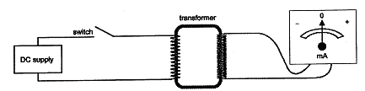

    - Name the Law and explain why the meter needle deflected when the switch is initially closed. (3 mark)

Lenz’s Law
When switch is closed, the current starts (increases). Changing current produces a changing magnetic field in the primary coil. This induces an emf in the secondary coil.
An induced emf will create an induced current which in turn causes the meter needle to deflect.

    - Explain why the needle returns to the original position even though the switch remains closed. (2 marks)

Once the current flow is established, because it is direct current, the current doesn’t changed and hence there is no changing magnetic field.
Without a changing magnetic field, you can’t induce an emf and therefore no current flows in the secondary coil.

- A coil has 400 turns with each of the coils having an area of 15.0 cm². The coil is placed in a magnetic field of flux density 0.800 T. What emf will be induced in the coil if the direction of the magnetic field is reversed in 2.45 s? (3 marks)

φ₂ = 15 x 10⁻⁴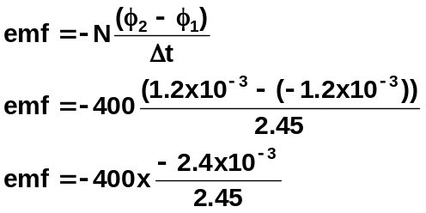 x 0.800
= 1.2 x 10⁻³ Wb
φ₁ = -1.2 x 10⁻³ Wb

emf = 0.392 V

- Pylons supporting high voltage (e.g. 500 kV) transmission cables tend to be very high and located away from populated areas.

- Apart from stopping people from touching them, why give one additional reason (related to the unit) as to why they might be located high up and away from populated areas?
(1 marks)

  - distance reduces radiation from electrical field
OR
  - reduces chance of induced emf in surrounding man made objects
OR
  - reduces risk to health due to electromagnetic radiation

- Give two reasons why electrical power is transmitted at very high voltages such as 500 kV?
(2 marks)

- P_{lost} = I²R. Reduce current means reduces power lost as heat
- As P = VI, if V is very large the current is small. Small current needs much thinner wires to transport so much cheaper.

- It is the morning of Alan’s Physics exam and he decided to test his knowledge while waiting for his toast to brown. His toaster is rated at 240V, 750 W. Show how he correctly calculated:
  - the current the toaster will draw. (2 marks)

P = VI
I = 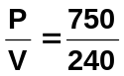 = 3.125
I = 3.13 A

  - the resistance of its element. (2 marks)

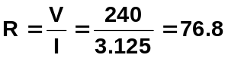

R = 76.8 Ω

  - The toaster takes 1.6 minutes to brown Alan’s toast. What charge passed through the element during this time? (2 marks)

E = P x t
= 750 x (1.6 x 60)
= 72000

E = 7.20 x 10⁴ J

- a. Which statement about a step-up transformer is correct?
A. Output current will always be larger than input current
B. Output current will always be smaller than input current.
C. The relative sizes of the output and input currents will depend on the specifics of the coil used.
D. The output current will only be smaller than the input current if the number of coils in the secondary coil is greater than the number in the primary coil.
Answer: ___ B ____ (1 mark)
b. Justify your answer for part (a). (2 marks)
In order for power input and power output to be equal (so as not to violate the law of conservation of energy), if voltage is stepped up, then current must always be lower.

Power constant and P = VI if V increases then I must decrease

- Consider the diagram of the transformer shown below. If the input voltage was 270 V, what would be the output voltage? (2 marks)
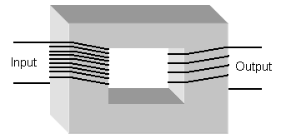

V_{p} = 270 V 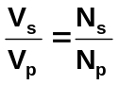
V_{s} = ? 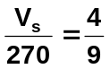
N_{p} = 9 turns
N_{s} = 4 turns 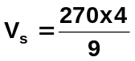

V_{s} = 120 V

